Credit Card Fraud Detection using Python

# Abstract:

Credit card fraud detection is a critical application of machine learning with uses in financial security, risk management, and real-time transaction monitoring. This project employs deep learning techniques using Python and TensorFlow to accurately identify fraudulent transactions based on historical data patterns. A pre-trained anomaly detection model is utilized to analyze transaction features, followed by specialized classification algorithms such as Random Forest and Neural Networks to differentiate between legitimate and fraudulent activities. The system enhances detection accuracy by incorporating feature engineering methods, including scaling and encoding techniques, to improve data representation. The final results are displayed through an intuitive dashboard with clear alerts for suspected fraudulent transactions. This approach provides a real-time, efficient, and scalable solution for fraud prevention, enabling its deployment in diverse financial applications.

# Introduction:

In recent years, machine learning and deep learning have revolutionized the field of financial security. Credit card fraud detection is an essential application of these technologies, widely used in banking systems, online transactions, fraud prevention strategies, and risk management. This project implements an automated fraud detection system using machine learning techniques and pre-trained deep learning models.

The system works by first analysing transaction patterns and features using historical data from legitimate and fraudulent transactions. Once a transaction is recorded, classification algorithms such as Random Forest and Neural Networks evaluate its features to determine whether it is potentially fraudulent. The results are then displayed through an intuitive dashboard, providing a real-time, efficient, and scalable solution. The project also integrates data preprocessing techniques such as feature scaling and encoding to improve detection accuracy. By leveraging pre-trained machine learning models, this project provides a robust, real-time, and user-friendly system for credit card fraud detection, making it suitable for a wide range of applications, from financial security enhancements to risk management optimization.

# Research Methodology:

## Basic Requirements:

To run this project successfully, the following software and hardware requirements must be met:

* **Operating System**: Windows (Adequately equipped machine)
* **Python Version**: 2.7 - 3.6
* **Libraries & Frameworks:** TensorFlow, Scikit-learn, Pandas, NumPy, Matplotlib
* **Development Environment**: PyCharm or VS Code

## Algorithm Workflow:

The algorithm is structured into **four main components**:

* Input
* Data Preprocessing & Feature Engineering
* Fraud Classification Model
* Output

## Input:

The system is designed to efficiently process transaction data for fraud detection. Users can input data through two methods:

* + - * **Live Transaction Stream:** The system monitors incoming transactions in real-time, allowing immediate fraud detection.
      * **Batch Processing:** Users can upload historical transaction datasets (CSV format) for analysis.

The input data includes features such as transaction amount, location, merchant details, user history, and device information.

## Data Preprocessing & Feature Engineering:

* + - * **Handles missing values:** Ensures clean data processing for accurate fraud detection.
      * **Feature Scaling & Encoding:** Normalizes numerical values and converts categorical data into meaningful numerical representations.
      * **Outlier Detection:** Identifies suspicious patterns in transaction features.

## Fraud Classification Model:

* + - * **Uses machine learning models like Random Forest and Neural Networks** trained on extensive transaction datasets.
      * **Anomaly Detection:** Flags transactions that deviate significantly from the user’s normal behavior.
      * **Predicts fraud probability with confidence scores** based on transaction characteristics.

## Output:

* + - * **Real-time Alerts:** Immediately flags suspicious transactions with a fraud probability score.
      * **Dashboard Visualization:** Displays trends, fraud likelihood, and transaction details.
      * **Automated Action:** Blocks high-risk transactions or alerts the user for verification.

# Steps for Practicing Credit Card Fraud Detection in Python:

1. Download and Prepare Data
   * The dataset includes real transactions with labeled fraud cases.
   * Common datasets: Kaggle Credit Card Fraud Detection, Synthetic Bank Transaction Data.
2. Parse Data Argument
   * Use **pandas** to load CSV transaction data.
   * Pre-process missing values and irrelevant features.
3. Initialize Models
   * Load pre-trained models such as **Random Forest, XGBoost, or Neural Networks** for classification.
   * Use **unsupervised anomaly detection models** for fraud flagging.
4. Set Model Parameters
   * Define key features: **Transaction Amount, Merchant ID, Device Type, Geo-location, Time of Transaction, and Frequency of Transactions**.
   * Establish thresholds for fraud probability scoring.
5. Train the Model
   * Use **Scikit-learn or TensorFlow/Kera’s** for training.
   * Employ **cross-validation** to enhance accuracy and avoid overfitting.
6. Deploy the Model for Real-time Detection
   * Implement a **streaming service** to monitor live transactions.
   * Use **Flask or FastAPI** for integration with financial systems.
7. Process Each Transaction
   * Analyze transaction features.
   * Predict fraud likelihood using trained models.
8. Identify Suspicious Transactions
   * If fraud probability exceeds a threshold (e.g., 80%), the transaction is flagged.
9. Data Display & Log Results
   * Generate fraud reports and display alerts.
   * Provide recommendations for action (e.g., transaction blocking or user verification).

# Code:

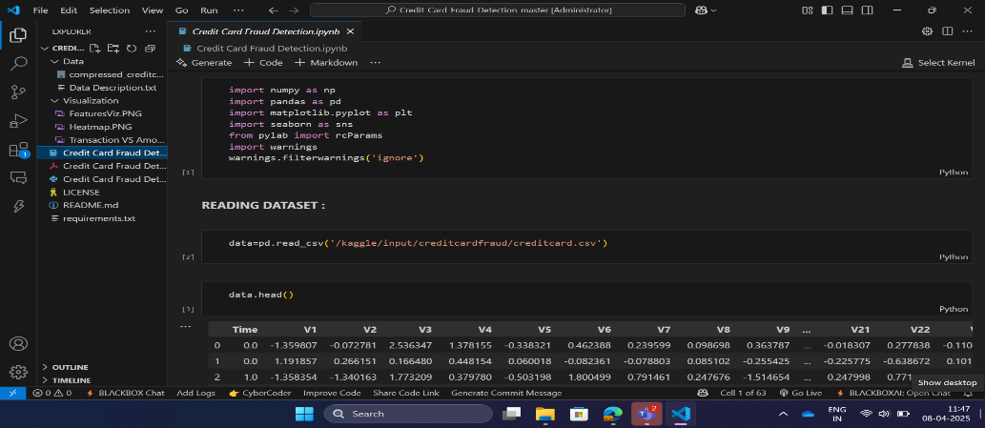

In this implementation, we provide a transaction dataset as input, and the system analyses the transaction patterns to detect potential credit card fraud. The model examines various features, such as transaction amount, location, time, and user behaviour, to identify anomalies that may indicate fraudulent activities.

If we provide real-time transaction data instead of a stored dataset, the system will analyse incoming transactions dynamically and flag potentially fraudulent transactions as they occur.

The output consists of a fraud detection result, indicating whether a transaction is classified as legitimate or potentially fraudulent based on the model's evaluation.

# Output:

# Use Cases:

Several uses cases for this project includes the following:

* **Detection of fraudulent transactions in real-time:** Identifying suspicious activities based on unusual spending patterns or transaction behaviors.
* **Risk assessment for financial institutions:** Helping banks and credit card companies assess and prevent fraud effectively.
* **Authentication of legitimate transactions:** Ensuring only authorized users carry out transactions to reduce unauthorized access.
* **Monitoring trends in financial fraud:** Analyzing past fraud cases to enhance predictive analytics and prevent future occurrences.
* **Security enhancement in e-commerce platforms:** Safeguarding online payment systems by detecting fraudulent purchases before they cause financial losses.

# Conclusion:

This project provides a real-time and automated credit card fraud detection system using deep learning. By leveraging advanced machine learning models, the system ensures accurate classification of fraudulent transactions across diverse financial activities. The modular design allows easy integration into applications requiring fraud analysis, such as banking security, e-commerce platforms, and payment gateways.

This implementation can be extended to include additional features like anomaly detection, user behavior profiling, and transaction pattern analysis, making it a powerful tool in the field of financial security and AI-based fraud prevention.